In-Class Assignment: RDBMS to Graph DB

Below are some of the questions that need your analysis to drive product strategy

1. List employees who sold Tofu with the count of orders.

1. What are the products sold along with Tofu?

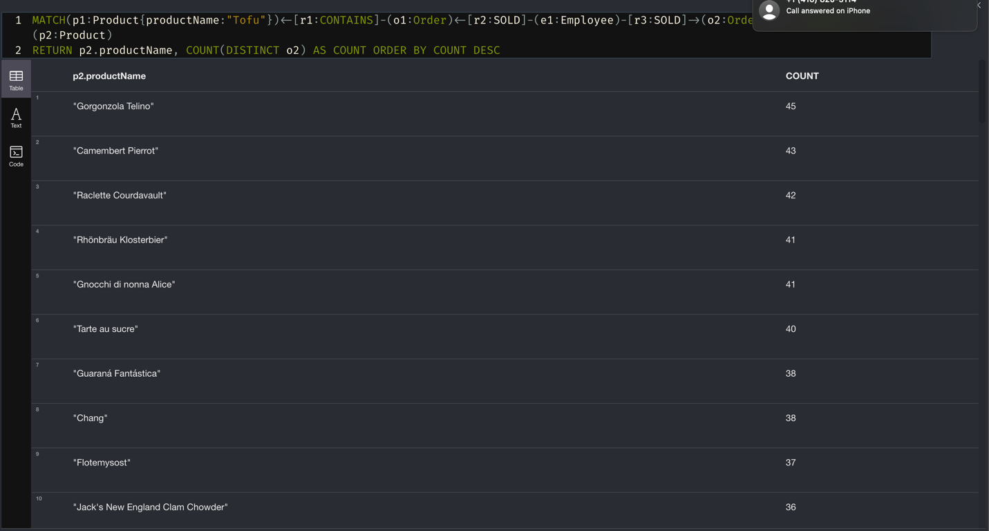

1. How many products do you have in your dataset?

1. What are the top 5 products by sales?

1. Which category has the highest sales (orders)? List the products in this category

